Responsive Web Design Project - Build a Survey Form

Fulfill the below [user stories](https://en.wikipedia.org/wiki/User_story) and get all the tests to pass. Give it your own personal style. You can use HTML, JavaScript, and CSS to complete this project. Plain CSS is recommended because that is what you have covered so far and you should get some practice with plain CSS.

**User Story #1:** I can see a title with id="title" in H1 sized text.

**User Story #2:** I can see a short explanation with id="description" in P sized text.

**User Story #3:** I can see a form with id="survey-form".

**User Story #4:** Inside the form element, I am required to enter my name in a field with id="name".

**User Story #5:** Inside the form element, I am required to enter an email in a field with id="email".

**User Story #6:** If I enter an email that is not formatted correctly, I will see an HTML5 validation error.

**User Story #7:** Inside the form, I can enter a number in a field with id="number".

**User Story #8:** If I enter non-numbers in the number input, I will see an HTML5 validation error.

**User Story #9:** s

**User Story #10:** For the name, email, and number input fields inside the form I can see corresponding labels that describe the purpose of each field with the following ids: id="name-label", id="email-label", and id="number-label".

**User Story #11:** For the name, email, and number input fields, I can see placeholder text that gives me a description or instructions for each field.

**User Story #12:** Inside the form element, I can select an option from a dropdown that has a corresponding id="dropdown".

**User Story #13:** Inside the form element, I can select a field from one or more groups of radio buttons. Each group should be grouped using the name attribute.

**User Story #14:** Inside the form element, I can select several fields from a series of checkboxes, each of which must have a value attribute.

**User Story #15:** Inside the form element, I am presented with a textarea at the end for additional comments.

**User Story #16:** Inside the form element, I am presented with a button with id="submit" to submit all my inputs.

Your output should be similar to this screen, dropd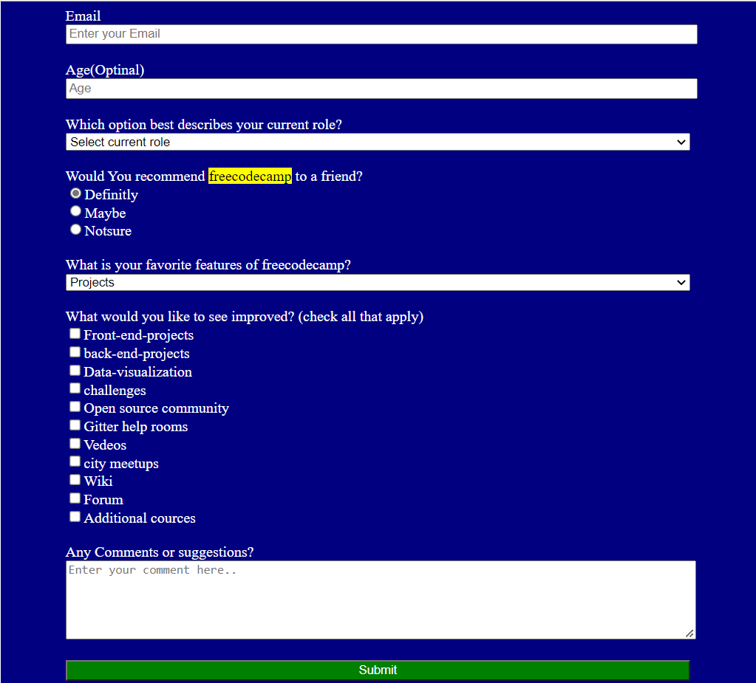own list, radio button, checkbox should all be included with basic validations.

